CHAPTER 3: Cells
Worksheet 3.5

Leafy exchanges
Student: Class:
Transpiration
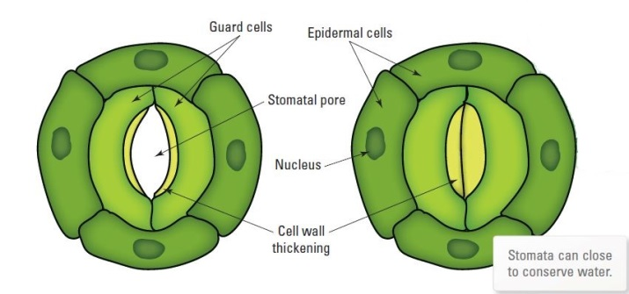
1. Consider the following two diagrams of the surface of a green leaf.
(a) Two stomates are shown. Explain why the stomatal pore at the left is open more widely than the one on the right.
The stomate on the left is more open as it is actively transpiring. The other stomate is closed as the plant could be under water stress.
(b) Define the term ‘transpiration’ in your own words.
Transpiration is the loss of water from a plant through its stomates. The transpiration stream draws water from the roots, up the stem and into the leaves.
(c) A student performed an experiment to measure the rate of transpiration using a bean seedling. She used the apparatus shown below.
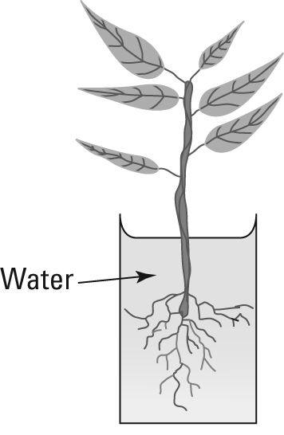 | (i) The student decided to place a thin layer of olive oil on the water surface before the experiment began. Explain why she did this.  To prevent evaporation from the water surface so she could see how the water level dropped due to transpiration alone  (ii) Explain how the student will measure the rate of transpiration.  Mark a scale on the side of the vessel. Measure the water level on this scale as a function of time.
Density of stomates
2. A student wanted to find out if there are more stomates on the top or the bottom surface of a leaf. She painted the bottom surface of a small section of a leaf with nail polish. When the nail polish was dry she peeled it off and observed it under the microscope. She could see imprints of the stomates in the layer of nail polish.
(a) Explain what the student will need to do next. (Remember that she wants to find out if there are more stomates on the top or bottom of the leaf.) Paint the top surface of a small section of the leaf with nail polish. Allow to dry and peel off the nail polish; then observe under the microscope as before..
(b) The student decides that instead of simply counting the stomates she should measure the density of stomates, i.e. how many stomates there are per cm² of leaf. Explain why this is necessary. The layer of nail polish peeled off the top and bottom surfaces may have different areas. She needs to control this variable. By counting how many stomates there are per square centimetre, she is ensuring that she compares the same area for the top and bottom surface.
(c) The student finds that there is a much greater density of stomates on the bottom surface of the leaf. Suggest an explanation for this. The bottom of the leaf is usually shaded from the sun and so this reduces water loss from the plant and prevents wilting.

